INVITATION TO TENDER FOR
BELOW-THRESHOLD PROCUREMENTS
SECTION B: TENDER SCHEDULES
TO BE COMPLETED AND RETURNED BY BIDDERS

Health Education England

Genomics Education Programme

Invitation to tender for provision of design services for the Genomics Education Programme

Date of advertisement on Contract Finder: 3rd July 2020

Authority's reference number: DN485700

Deadline for Tenders to be received: 24th July 2020 at 4pm

Supplier Name:

ANNEX B3
TENDER RESPONSE DOCUMENT

Note to Bidders: Your response to this Annex B3 will form part of the Specification and Tender Response Document as defined in the Contract. As such, it will form part of your contractual obligations to the Authority if you are awarded a contract.
- TECHNICAL AND QUALITY QUESTIONS AND METHOD STATEMENTS

Overview
  - Please provide a concise summary highlighting the key aspects of the proposal. (This response is not evaluated and should be used to contextualise your detailed responses).

Response maximum 1,000 words

The proposal
- An exciting new Genome project
- Online educational training
- Engaging, accessible and clear
- Posters, flyers, postcards, info-graphics and animation

Why I am a suitable candidate:
- Many years experience in illustration, design and animation
- Experienced in project management
- Excellent record-keeping and data handling
- Understanding of the need for confidentiality
- Good communication skills
- Cost effective

Confirmation of full compliance with specification
  - See Annex B2, which you must complete.

Method statement questions

Q1 - Outline your understanding of the tender requirements and your planned approach to deliver this service (Maximum 1000 words)

This looks to be a really exciting new project for The Genomics Education Programme (GEP).

The programme will provide education and training resources to a variety of NHS experts. It aims to offer predominantly online educational, training and awareness-raising content – recognising the importance of multimedia and social media to make its content engaging, accessible and as clear as possible.

The project requires posters, flyers, postcards, info-graphics and animation to make the information as creative and engaging as possible.

Q2 - Demonstrate the expertise of staff that would be working with the GEP. (Maximum 1000 words)

I graduated from Chelsea School of Art and I have been a professional illustrator for over 20 years (I attach my CV). I have worked in educational publishing for most of my career. I am very familiar with interpreting complex information in a clear and graphic way.

I have worked with many of the major scientific publishing houses including: A&C Black, AbD Serotec, British Medical Journal, British Society of Surgeons for the Hand, BUPA, Cambridge University Press, Clinical Pocket Reference Ltd, Garland Science, Improve International, Nuffield Orthopaedic Centre, Open University, Oxford Pharmagenesis, Oxford University Press, Royal College of Nursing, Royal College of Obstetricians and Gynaecologists, The British Dental Journal, Toynbee Editorial Services, University of Oxford.

For over 20 years I was a senior illustrator at Oxford Designers & Illustrators Ltd and I have been a Freelance Illustrator for over three years. During my time at OD&I I project managed many titles, I also took on the role of department manager and was involved in commissioning artwork. I am still in touch with all of my work colleagues (who are all now freelancing) so I have access to a large team with a variety of styles.

I am highly proficient at working in Adobe Illustrator, Adobe Photoshop and Adobe Animate and can provide artwork in any format.

I have produced everything from simple illustrations for students’ books to large posters for exhibitions, from patient information booklets to animations for websites.

Although I am a sole trader, I have handled large projects both on my own and with the help of other trusted freelancers. I have turned around large quantities of artwork in a matter of days and am always willing to work tirelessly until a project is complete – and I am quite happy to work to tight deadlines.

I back up all of my work daily and keep copies in case of any technical issues.

I have also worked on several projects for The Standards And Testing Agency, so understand the need for high confidentiality and all work is to be treated and supplied in a secure fashion.

Q3 - Describe the approach to the development and management of projects, outlining key roles, phases of development, and expected input from and contact with the GEP. This should include approach to dealing with briefs at short notice with a tight deadline - though we take steps to keep these to a minimum. (Maximum 1000 words)

I am used to working from very sketchy, complex briefs and condensing and translating those into attractive and informative images.

Once the brief has been supplied I always provide a first draft of the artwork or animation (usually as a JPG/PDF or animated GIF). For illustrations and info-graphics this is often approved first time so I would then supply the final artwork as a flight-checked PDF, however – sometimes the information is more complex so requires some clarification. For this, once this first draft has been approved I will then go forward to producing the final artwork which is a vector file so can be reproduced to any size or format.

For large posters I will produce a screen-sized proof for checking before supplying the final-sized artwork.

For animations, I will produce the artwork on a storyboard with timings to double-check everything is acceptable before proceeding with the first draft of the animation.

As your point of contact, I am always available to discuss the project either by email, ‘phone or online via Skype, Zoom or MS Teams. I find this personal approach to be very beneficial as it means I can build up an understanding of your needs very quickly.

I am also very used to working to a tight deadline – with so many years of experience I can turnaround jobs at a fast and high rate.

I understand the need for confidentiality with these projects, so all artwork is supplied as a password-protected PDF where possible.

Q4 - Provide a range of high-quality examples of a broad portfolio of work, including print, digital, infographics, iconography and animation. Please highlight examples of technical and creative excellence in conveying sometimes complex information in an accessible, stimulating way. (Maximum 1000 words – Please attach or link to a PDF, slide deck, web page or similar with examples of work. The word count can be used to give context and detail around each example / set of examples.)

I have produced countless illustrations, info-graphics and animations and I have provided a small selection of diagrams on a dedicated web link.

Often I am provided with a very sketchy brief or a very complex set of information – and it is my job to represent that in a clean, graphic, informative (and sometimes fun) way.

I have several 5* reviews and positive testimonials.

Click here to go to my Genomics Education Programme web page.

https://www.chatterboxillustration.co.uk/gep

Promotional material | Iconography | Scientific poster | Pull-up banner | Social media graphics | Factsheets | Data and charts | Animation
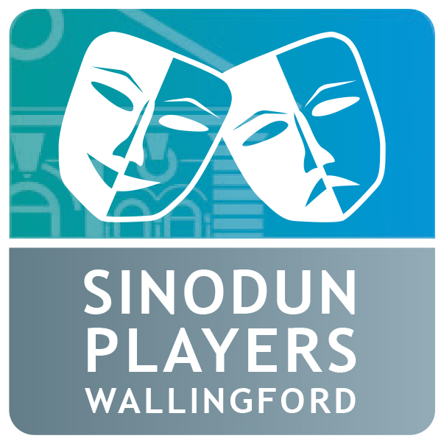 |  | 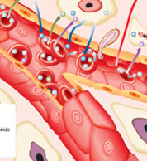 |  |  | 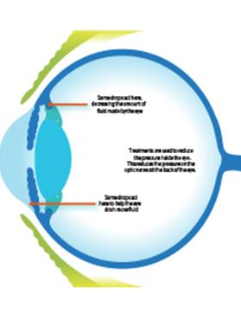 | 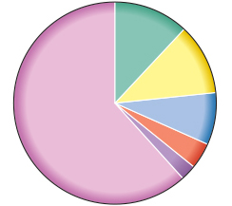

Sub-contractors
  - Please specify any areas or elements for which you wish to use a subcontractor and provide the following details:
    - which subcontractor you wish to use and for what elements;
    - what reasons you have for such subcontracting;
    - why particular third parties would be chosen;
    - any existing relationship with each such subcontractor; and
    - how you would ensure that appropriate management controls would be put in place.
  - Please explain what contractual arrangements you have (if any) with subcontractor(s) to ensure that your obligations to the Authority will adequately flow down to the subcontractor(s).

Response

As I am a freelance illustrator I do not have to report back to any other agency and your project would be the only one I would handle once it got underway.

